Q1. How many users does Wave have?

Should return total number of users you have in your database

SELECT COUNT(u_id)

FROM users

Count should be performed on the u_id column

Q2. How many transfers have been sent in the currency CFA?

SELECT COUNT(transfer_id)

FROM transfers

WHERE send_amount_currency = 'CFA'

Count could also be done on the send_amount_currency column

Q3. How many different users have sent a transfer in CFA?

SELECT COUNT(DISTINCT(u_id))

FROM transfers

WHERE send_amount_currency = 'CFA'

*DISTINCT is required to get different users

Q4. How many agent_transactions did we have in the months of 2018 (broken down by month)?

SELECT DATE_PART('month', when_created) months, COUNT(agent_transactions) agent_transactions

FROM agent_transactions

WHERE DATE_PART('year', when_created)=2018

GROUP BY 1

Sample expected output

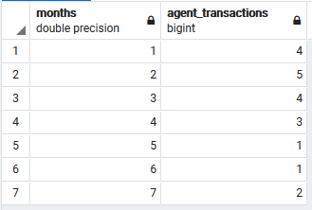

Q5. Over the course of last week, how many Wave agents were “net depositors” vs “net withdrawers”?

SELECT AgentType, COUNT(DISTINCT agent_id)

FROM

(SELECT (agent_id), SUM(amount) AS net,

CASE WHEN SUM(amount) < 0 THEN 'Net withdrawer'

     WHEN SUM(amount) > 0 THEN 'Net depositor'

END AS AgentType

FROM agent_transactions

WHERE when_created > now()-interval '1 week'

GROUP BY agent_id) sub

GROUP BY 1

;

Where clause should have a 7-day interval, could be written differently from what is here

Sample expected output

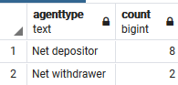

Some students may use subqueries as above or multiple queries to arrive at the result, try them out.

Q6. Build an “atx volume city summary” table: find the volume of agent transactions created in the last week, grouped by city

SELECT agents.city, SUM(ABS(atx.amount)) as transaction_volume

FROM agent_transactions atx

JOIN agents ON atx.agent_id = agents.agent_id

WHERE atx.when_created >= now()-interval '1 week'

GROUP BY agents.city;

*some consider volume as total amount and others consider it as total number of transactions. Consider both scenarios if a student uses any of them.

Sample expected output

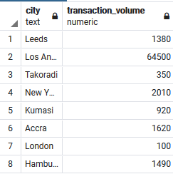

Q7. Now separate the atx volume by country as well (so your columns should be country, city, volume)

now()-interval '1 week'

GROUP BY 1, 2;

Sample expected output

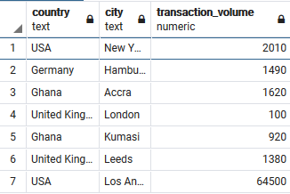

Q8. Build a “send volume by country and kind” table: find the total volume of transfers (by send_amount_scalar) sent in the past week, grouped by country and transfer kind.

SELECT SUM(transfers.send_amount_scalar) as send_volume,

       wallets.ledger_location as country, transfers.kind

FROM transfers

JOIN wallets ON transfers.source_wallet_id = wallets.wallet_id

WHERE transfers.when_created >= now()-interval '1 week'

GROUP BY 2, 3

SELECT agents.country, agents.city, SUM(ABS(atx.amount)) as transaction_volume

FROM agent_transactions atx

JOIN agents ON atx.agent_id = agents.agent_id

WHERE atx.when_created >=

Sample expected output

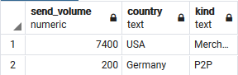

Q9. Then add columns for transaction count and number of unique senders (still broken down by country and transfer kind)

SELECT SUM(transfers.send_amount_scalar) as send_volume,

       wallets.ledger_location as country, transfers.kind,

       COUNT(transfers.transfer_id) as total_transfers,

       COUNT(DISTINCT transfers.u_id ) as unique_senders

FROM transfers

JOIN wallets ON transfers.source_wallet_id = wallets.wallet_id

WHERE transfers.when_created >= now()-interval '1 week'

GROUP BY 2, 3

Sample expected output

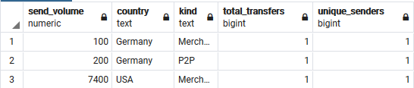

Q10. Which wallets have sent more than 10,000,000 CFA in transfers in the last month, and how much did they send?

SELECT source_wallet_id,

       SUM(send_amount_scalar) as volume_sent,

       send_amount_currency, when_created

FROM transfers

WHERE send_amount_scalar > 10000000

      AND send_amount_currency = 'CFA'

      AND when_created >= now()-interval '1 month'

GROUP BY 1,3,4

Sample expected output

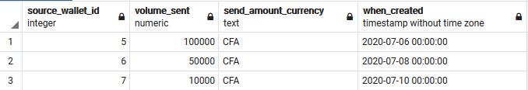

* smaller figure was used in this table. Required columns are wallet id and volume sent